“ FOUNDER’S DAY “

85th ANNIVERSARY OF AA
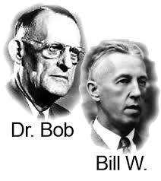 SUNDAY -JUNE 7th -1 pm
Meeting place CARBONDALE COLORADO

ERIKA H, DILLON H-
& JOHN B
FELLOWSHIP/ FUN/ FOOD [ open meeting]

