SILT WILD BUNCH WEENIE ROOST
FRIDAY, JUNE 12
Veteran's Park, Silt, CO
Join us for fun, fellowship, good food, great company, and small-town spirit!
Potluck starts at 6:00 PM with a meeting to follow.
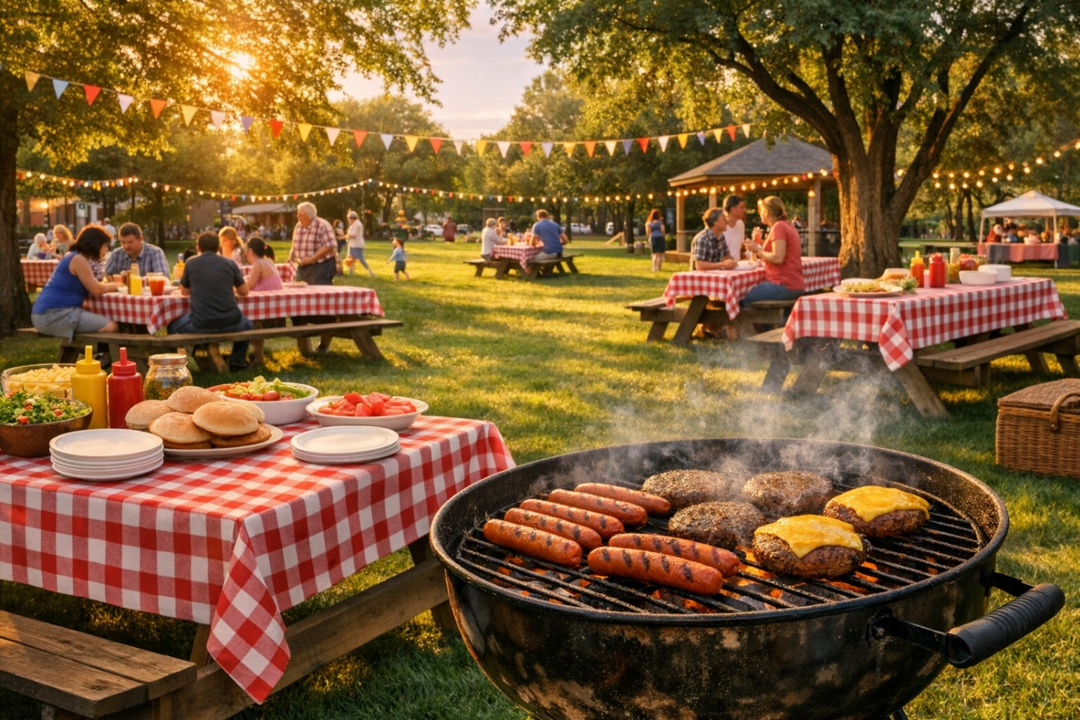Weenies and burgers provided — please bring a dish to pass.
Please bring a chair!

